The ER Diagram of the Mercado Escolar consist of sevent entities and their relationships as follows:

Student

Club

Many to many relationship (A student may no participate in any club. Thus, Optional participation form student end.)

Student

Product

Many to many relationship (A student may not advertise or buy any product. Thus, Optional participation form student end.)

Business Owner

Product

Many to many relationship (Full participation form both end.)

Order

Product

Many to many relationship (There is no order without product but there can be a product without order. Thus, Optional participation form product end.)

Super Admin

School Admin

One to many relationship (Full participation form both end.)

School Admin

Business Owner

One to many relationship (There can be a school admin who manages only students. Thus partial participation form school admin end.)

School Admin

Students

One to many relationship (There can be a school admin who manages only business owners. Thus partial participation form school admin end.)

The complete ER Diagram is given below:

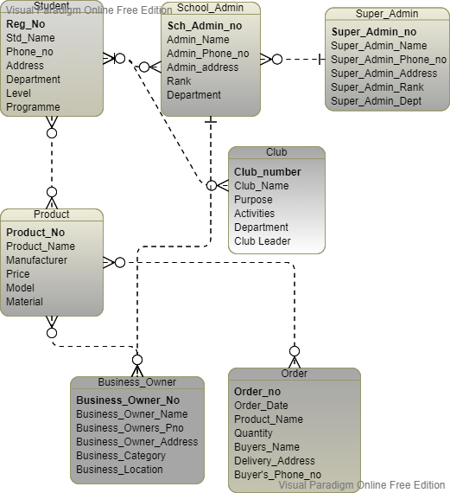

Figure 1 ER Diagram for the Mercador Escolar Shopping Web Application